The Digital Divide
The use of computer technology in a classroom, whether in a large Ontario city, a small town, or in a third world country, can allow students to become more in touch with the outside world, and promote equity. Information technology can become the link between the school and the real world.
Technology is more than a symbol to teachers, parents and students that schooling can and will change, that classrooms may have some bearing on the 21st century. It can be used by you to promote justice and equity with those who have less.
Global Digital Divide
The global digital divide is a term that refers to the great difference between developed countries and developing countries in the access their people have to computers, the Internet, and other digital technology.
In developing countries there is very little money for extras such as computers, cell phones, and MP3 players. Life in these countries is primitive by our standards. We can easily take technology for granted.
To a large extent, the global digital divide is a matter of rich versus poor. In addition, a country’s infrastructure, education system, and cultural factors also influence access to technology.
A developing country in Africa might not have the phone systems, satellite connections, or fibre optical networks to allow high speed Internet connections. For example, only about 50% of the world’s population has access to a phone line. Even electrical power is not available or may be unreliable in some regions of the world.
A country might have the money for computers and networks, but its education system might not include training in the effective use of this technology.
The culture of some developing countries is based on the village and relies on face-to-face interactions as opposed to online communications.
The digital divide is a growing problem. Every time new technology arrives in the developed countries, the countries on the other side of the divide fall further behind. On the other hand, some people feel that the global digital divide is closing with advances like wider access to mobile phone networks throughout the world.
The global digital divide has a ripple effect. The developed countries use their advanced technologies to reap enormous benefits including better education, better employment, and greater wealth. The rich get richer and the poor get poorer.
Disposing of Computer Equipment
The advance of computer technology leaves a flood of obsolete equipment in its wake. Every year more and more computers and related hardware like printers, scanners, and cameras become unwanted, redundant, or broken. Various experts put the life span of a computer in a business at between two and four years.
As many as twenty million computers in Canada will soon become obsolete. What becomes of this unwanted computer hardware? Where does broken equipment end up?
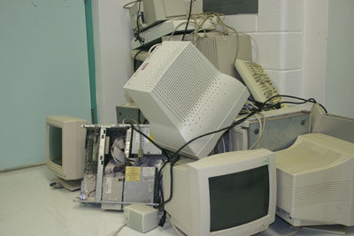
There is a huge growing problem of disposing of obsolete hardware. More and more of this equipment is appearing in our landfill sites. Besides the sheer volume, there are serious concerns that this material is, in fact, toxic waste. Used computer equipment such as monitors contains heavy metals (like lead, cadmium and mercury), PCBs, and other poisonous substances.
Can the three R’s – Reduce, Reuse, and Recycle - be applied to technological garbage?
Manufacturers of today’s new technology must be forced to use less toxic material in making the equipment so that in the future it will be safe to deal with at the end of its useful life.
What is the solution?
There are several ways in which computer equipment can be recycled. Some companies can break down old hardware into valuable materials that can be used in the manufacture of new things. A pile of old computers can actually be “mined” for precious metals like gold.
Many corporations, businesses, and government agencies employ another form of recycling. When they replace working equipment that they deem out-dated (such as five-year-old computers) they donate it to companies, charities, agencies, or individuals who have need of this technology.
Whenever a company or government department parts with a compute, there is always the danger of confidential or even secret information still being on the computer hard drives. There must be strict policies and procedures to erase or destroy this information before the computer is recycled or even before it is taken to a landfill site.

