Unit 5: Immigration Source Deconstruction Challenge
Source Interpretation
Examine each source in this challenge. Use your knowledge and understanding of the Social Studies 9 Immigration Unit and the issues that were presented, in addition to the information provided by the sources to answer the question in paragraph form.
You are required to:
- Interpret each source and identify and explain the point of view and its relationship to immigration
- Analyze the implicit and explicit messages
- Identify the perspective and relationship to the issues examined in the Immigration Unit
- Establish a link between the point of view and the issues of immigration
- Identify and explain one or more relationships that exist among the sources

Source 1
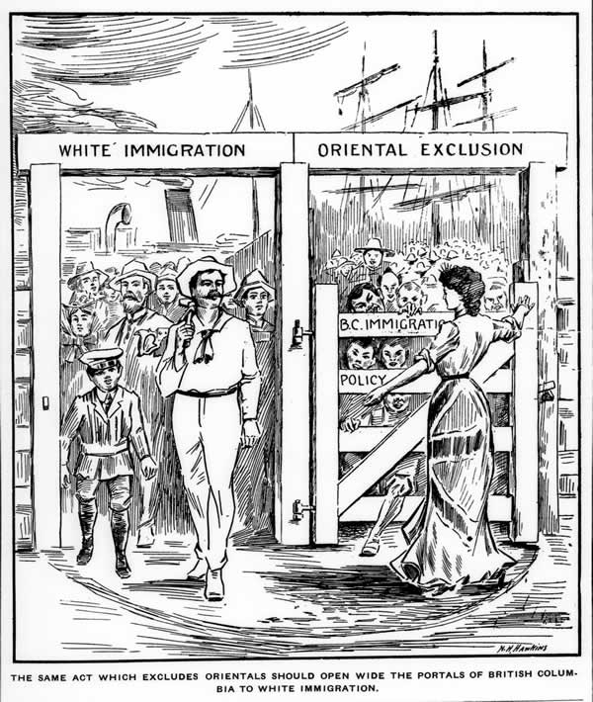
The same act which excludes Orientals should open wide the portals of British Columbia to White immigration.

Source 2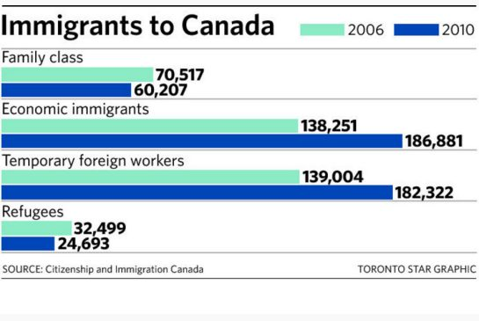
Source 3
Security
Health
Politics
Some factors related to Canada’s policies on immigration and migrant workers.

Economics

