Source Analysis
Ethnocentrism:____________________________________________________________________________________________________________________________________________________________________________________________

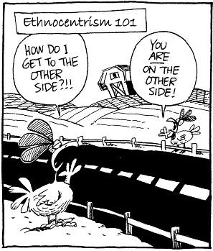
Explicit Analysis:____________________________________________________________________________________________________________________________________________________________________________________________________________________________________________________________________________________________________________________________________________________________________________________________________________________________________________________________________________________________________________________________________________________________________________________________________________

Implicit Analysis:____________________________________________________________________________________________________________________________________________________________________________________________________________________________________________________________________________________________________________________________________________________________________________________________________________________________________________________________________________________________________________________________________________________________________________________________________________
Eurocentrism:_____________________________________________________________________________________________________________________________________________________________________________________________

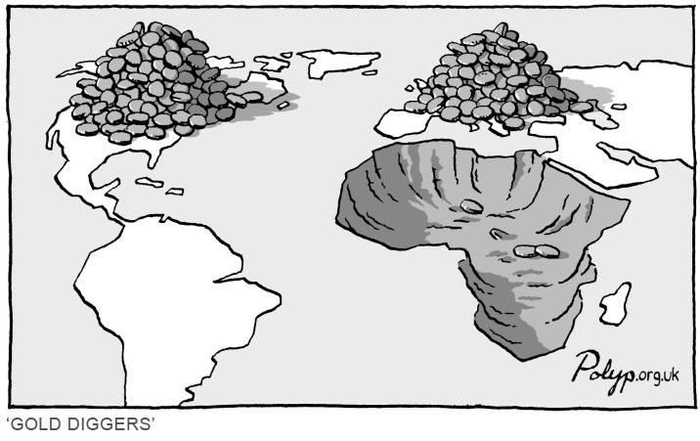
Explicit Analysis:____________________________________________________________________________________________________________________________________________________________________________________________________________________________________________________________________________________________________________________________________________________________________________________________________________________________________________________________________________________________________________________________________________________________________________________________________________

Implicit Analysis:____________________________________________________________________________________________________________________________________________________________________________________________________________________________________________________________________________________________________________________________________________________________________________________________________________________________________________________________________________________________________________________________________________________________________________________________________________

