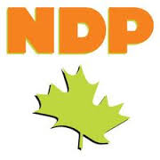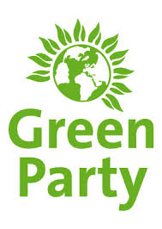



**Centre**

**Maintain spending**

**Support change if most want it**

**Improve lives of citizens**

**Protect rights of individuals**

**Balance society & offenders interests**

**Economic mix of public and private ownership**

**Left Wing**

**Reduce military spending**

**Improve welfare for citizens**

**Greater social programs**

**Protect everyone fairly**

**Less police power**

**Legal rehabilitation, not jail**

**Government should control key resources**

**Right Wing**

**Increase military spending**

**Maintain tradition and be cautious to change**

**Private business should ensure needs of citizens and own resources**

**Maintain law and order**

**More police power**

**Severe punishments in legal system**