Starter: Compete in an information race
Using your cell phone (or other hand held information-gathering device) or a computer, find all of the information below as quickly as possible. As you find the data, record it in the designated area in your student booklet.

- What is the present temperature in Buenos Aires __________

- Who is the current leader of Latvia __________________________

- Use Google earth to zoom in on a picture of your high school. Record the exact amount of time it took you to get the information from the moment you type it in. _________________ minutes

- Translate the phrase "I am an amazing grade 10 student" into at least 3 foreign languages.
Language | Translation

- Visit city-mankato.us and list 3 of the most interesting things a tourist could see if they visited Mankato, Minnesota.
- _______________________________________________________________
- _______________________________________________________________
- _______________________________________________________________

- Google your first name and note how many results come up ______________________

- What is the local phone number of your MP's office? _____________________________

- What is Nelson Mandela's middle name? ______________________________________

- Visit dhmo.org to find out three effects of the chemical dihydrogen monoxide.

- _______________________________________________________________
- _______________________________________________________________
- _______________________________________________________________

- What is the population of your home town?_____________________________________

Reflect: Explain three observations (or new things you learned about media, using the
Internet, etc.) from this activity.

Create a list of Media
Media, in its many varied forms is a way we learn about the world. In pairs list all of the types of media sources you can think of here:
Record your favourites
Consider the first column of the chart below. What are your favourites in each of the categories? Try to think of at least 2, even if it's something that was your favourite a long time ago. After designating your favourites, check whether they are from Canada, the United States or from somewhere else. For example, if you decide to include "The Cat in the Hat" by Dr. Suess as one of your favourite books because you just loved it when you were little, find out where Dr. Seuss is from (USA). You may need to do a bit of research to determine the origins of your favourites.

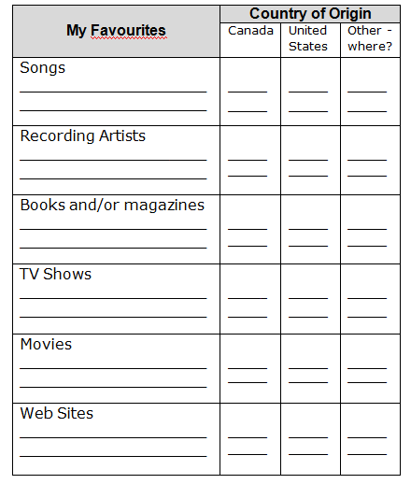
Some Questions
- What does CRTC mean? What is its mission?

- Is it important to have CANCON in the Canadian media? Why or Why not?

- What is Diversity? How does it compare to cultural homogenization?

- What is Media Convergence? What is media concentration? Why are together they are both such a concern?

- How are hybridization and universalization of media connected?

Analyze this Source
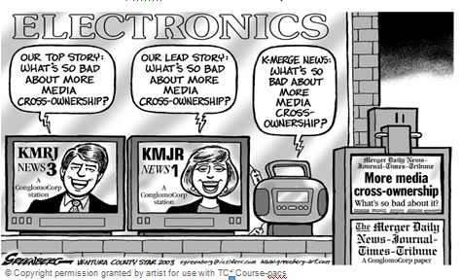

- What is the explicit message?

- What is the implicit message?

- What perspective or point of view of the artist?

- What evidence supports the artists point of view?

