Map Analysis
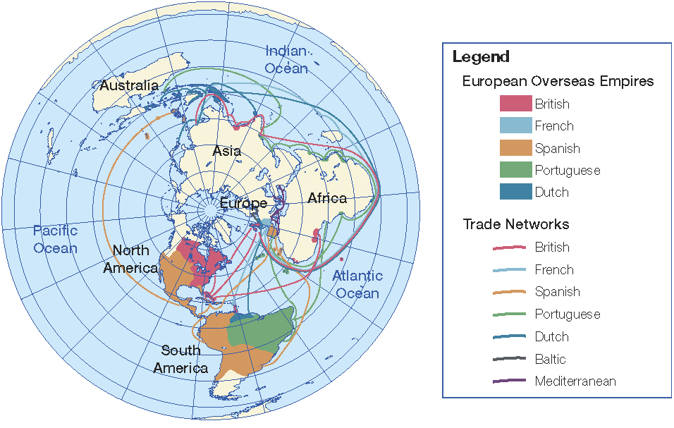
1. What projection is used for this map?

2. Why might this projection be used to show information about trading empires in 1770?

3. What are some advantages and disadvantages of using this projection?

4. Which parts of the world had been colonized by 1770?

5. Why might these regions have been colonized while other regions were still not colonized?

6. What challenges does the map suggest European traders faced as they tried to reach these colonies?

