How Do Taxes Work?
The government collects taxes to pay for the services it provides to citizens, such as social programs. In Canada, both the federal and provincial governments collect taxes. The federal governments transfers some of the taxes it collects to the provinces for Health and Social programs.
Income Tax is based on what you earn: the more money you earn, the more tax you pay.
Sales Taxes are based on what you spend on products and services: the more you spend, the more tax you pay.
Goods and Services Tax (GST) is a sales tax that everybody in Canada pays.
Provincial Sales Tax (PST) is a sales tax that only members of specific province pays.
Harmonized Sales Tax (HST) is a sales tax that combines both PST and GST for a single value tax.
* Note that Alberta residents only have to pay a GST and not a Provincial Sales Tax (PST)
Current Tax Rates Provincially
Province | GST | PST | HST | Total Taxes
Nova Scotia |  |  | 15% | 15%
Quebec | 5% | 9.975% |  | 14.975%
PEI |  |  | 14% | 14%
Manitoba | 5% | 8% |  | 13%
New Brunswick |  |  | 13% | 13%
Newfoundland |  |  | 13% | 13%
Ontario |  |  | 13% | 13%
British Columbia | 5% | 7% |  | 12%
Saskatchewan | 5% | 5% |  | 10%
NWT | 5% |  |  | 5%
Nunavut | 5% |  |  | 5%
Yukon | 5% |  |  | 5%
Alberta | 5% |  |  | 5%

How much will it cost if you buy…
Product | Initial Cost | Alberta (5%) | British Columbia (10%) | Nova Scotia (15%)
Bag of Chips | $3.99 | 4.18 | 4.39 | 4.59
Flat Screen TV | $599.00
Quad | $9000.00
Truck | $45,000.00

What is a taxation model?
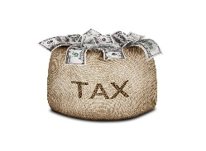

Job & Income Individuals Taxes Government

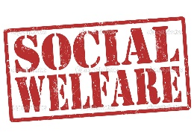
Income Assistance
Education
Healthcare Policing

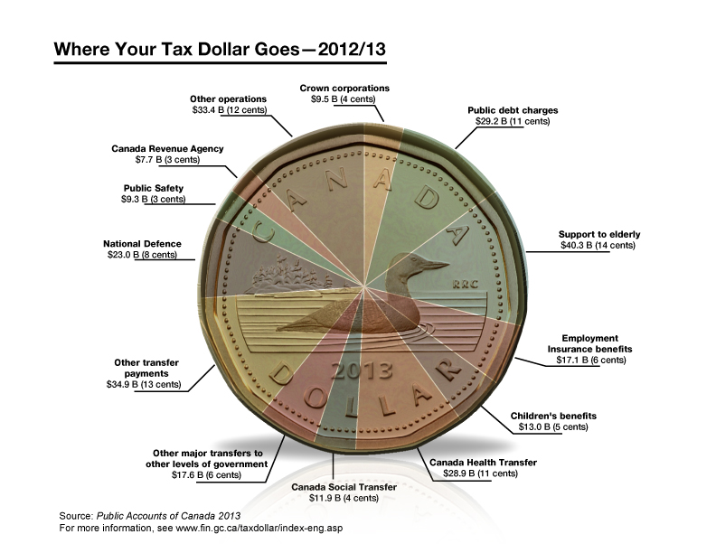
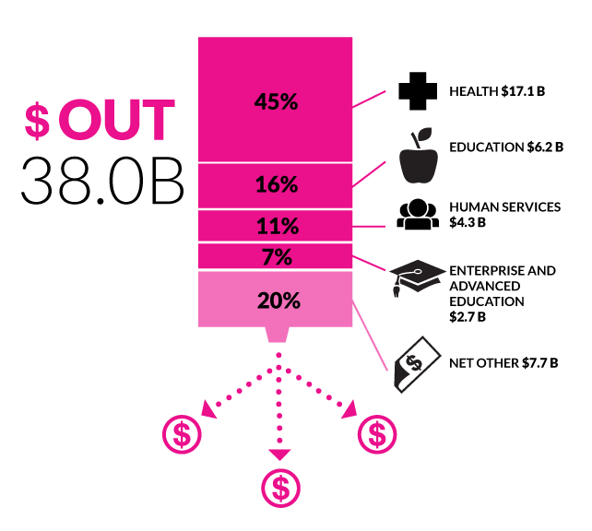

Black Market is another term for underground economy.
Tax Base is all of the economic activity in a society, taxed by government to pay for services.
Tax Evasion is misrepresenting what you earn to avoid paying taxes.
Taxation Model is a policy of a political party or government about what to tax and how much.
Underground Economy is economic activity based on buying and selling products/services illegally.

Lesson Questions
1. Based on the taxation model, how can tax evasion affect programs and services for everyone? How might this affect quality of life?

2. How does the economic decision making about taxes affect the quality of life of individuals?

3. Do you believe that the distribution of tax dollars indicated in the diagrams above are appropriate? Does the distribution reflect the values you support?

