Early Numbering Systems
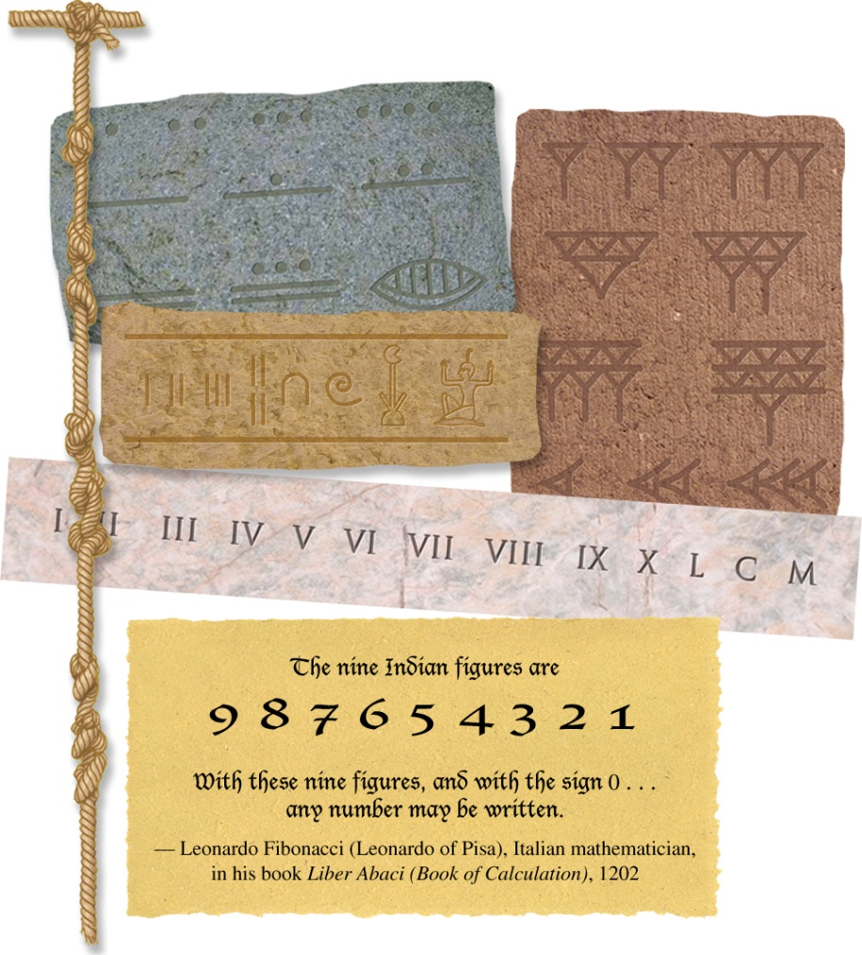

How many different counting systems can you see? Which can you identify?

What trade difficulties might have arisen when a buyer and a seller used different number systems?

What benefits do you think might have been seen in the Indo-Arabic numerals?

Why do you think the Indo-Arabic number system came to be so widely used?

How might the development of a uniform international number system affect merchants?

How might the use of a single number system contribute to globalization?
The Silk Route
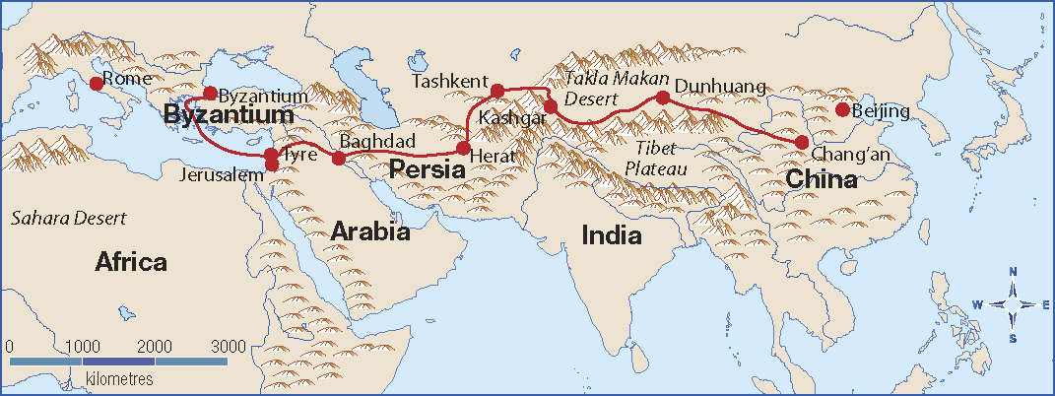

What countries did the Silk Route pass through?

What are the present day names of the countries along the Silk Route?

How long was the Silk Route?

What goods were carried along the Silk Route?

What effects did the Silk Route in the countries it passed through?

In what ways did the Silk Route contribute to historical globalization?

