Create Your Own Coat of Arms
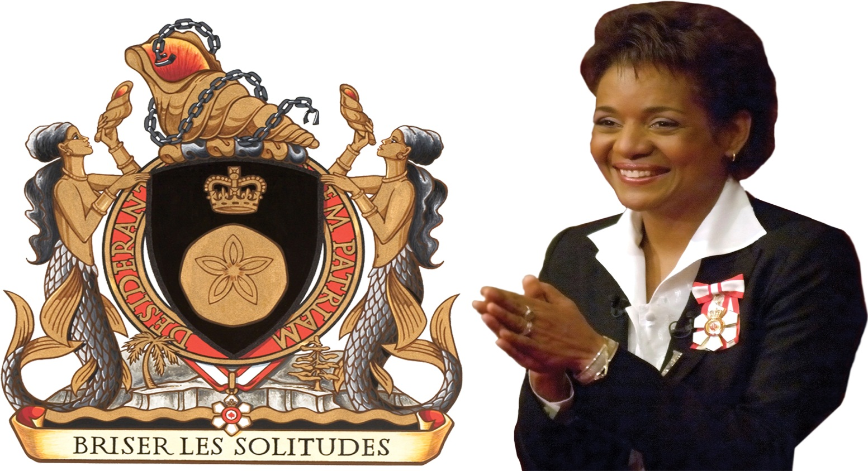

Michelle Jean, who was born in Haiti, became the Governor General of Canada in 2006. Her personal coat of arms, shown here, includes words and symbols from Africa, Haiti, and Canada, the cultures that have helped shape her identity.

Your Task:
You will create your own coat of arms to affirm your language and culture. You can do this digitally, or by hand. You will have approximately 1.5 classes to complete this assignment and submit it for assessment. Ensure that you review the checklist of success criteria for your coat of arms.
For ideas, visit http://www.makeyourcoatofarms.com/index.asp

Success Criteria:
- Includes 3 symbols from your heritage/culture
- Includes 3 words or sayings from your heritage/culture
- Includes colour
- Is in proper coat of arms format
- Includes complete paragraph explaining choices for symbols and words

1 = Incomplete 2 = Minimal 3 = Some 4 = Considerable 5 = Thorough
Criteria | Assessment Criteria
Use of Symbols | 1 2 3 4 5  Minimum 3 symbols are appropriate to language, culture, and heritage of individual
Use of Words | 1 2 3 4 5  Minimum 3 words or motto/slogan are appropriate to language, culture, and heritage of individual
Use of Colour | 1 2 3 4 5  Colour is represents mood of coat of arms, and is representative of culture.
Format | 1 2 3 4 5  Coat of arms is in proper format, with no missing components.
Paragraph | 1 2 3 4 5  Paragraph fully explains reasoning for symbols, words/motto/slogan, colour and gives overview of individual’s culture, heritage, and identity.

